ORIGINAL ARTICLE:

Adrenal insufficiency associated with advanced HIV may explain the high mortality.

TRP Mofokeng¹, A Grossman³, RS Millar⁵, TS Pillay⁶, JB Sempa⁷, B Aslan⁸, G Nitschke⁸, J Singbo², J Dave², NS Levitt², R Erasmus², PJ Raubenheimer², C Dandara², G Johansson⁴, IL Ross²
1Division of Endocrinology, Department of Medicine University of the Free State, South Africa 2Division of Endocrinology, Department of Medicine University of Cape Town, South Africa 3Department of Endocrinology, St Bartholomew’s Hospital, London, UK
4Department of Endocrinology, Sahlgrenska Academy, Sahlgrenska University Hospital and Institute

of Medicine, University of Gothenburg, Gothenburg, Sweden
5Department of Immunology, Faculty of Health Sciences, University of Pretoria, Private Bag X323, Pretoria 0031, South Africa
6Department of Chemical Pathology and National health Laboratory Servi Tshwane Academic Division, Faculty of Health Sciences, University of Pretoria, South Africa
7Department of Statistics University of the Free State, South Africa
⁸Department of Computer Science, University of Cape Town, South Africa
Tygerberg Hospital, National Health Laboratory Service, Faculty of Medicine, Stellenbosch University, Cape Town, South Africa
Division of Human Genetics, Univ of Cape Town 2. DIRECTOR: Platform for Pharmacogenomics Research & Translation

Correspondence should be addressed to: Dr Thabiso RP Mofokeng,
Division of Endocrinology,
Department of Medicine (University of the Free State) South Africa,
e-mail: mofokengtrp@ufs.ac.za

Abstract:
Background:
Sub-Saharan Africa is burdened by a vast HIV-positive population, at risk of life-threatening AIDS defining illnesses and disseminated opportunistic infections, which have been associated with both primary (PAI) and secondary adrenal insufficiency (SAI). We hypothesized that adrenal insufficiency (AI) may partially account for the high mortality in advanced HIV.

Materials & Methods:
We undertook a prospective case-finding study of HIV-positive patients presenting with advanced disease, who were 18 years or older, with a CD4 count of less than 100 cells/ mm³, and a coexistent opportunistic infection. Exclusion criteria were use of oral, intravenous, topical or inhaled steroids in the previous 3 months.

Results
Of 589 recruited patients, 563 had complete records for evaluation. The median interquartile range (IQR) age of patients at enrolment was 36.0 years (IQR: 31.0-43.0). Of 563 patients, 56 (9.94%) had AI by tetracosactide test and random cortisol < 274 nmol/L with 45 (80.35%) having (SAI) and 11 (19.64%) (PAI). Duration of illness was longer in the SAI versus the PAI group: 14 days (IQR:14.0, 23.3) versus 10 days (IQR: 7.0, 14.0); p=0.024 with significant vomiting in the PAI vs SAI group (66.7% vs 23.1%) p=0.038. Patients in the lowest CD4 tertile were younger with more candida albicans, p=0.003. Pulmonary tuberculosis (PTB) predominates in the non-AI, whereas Cryptococcus neoformans predominates in the AI group 64.5% vs 45.7%, p=0.026 and, 31.4% vs 3.7%, p<0.001, respectively.
The overall one-year mortality for the whole cohort was 29.12%. Regression analysis revealed that a 50 nmol/L cortisol increase, and 100 pg/L increase in the plasma ACTH were associated with a 14% and 17% increase in the odds of mortality (OR = 1.14, (95%CI: 1.08, 1.21), p<0.001) and (OR = 2.17, (95%CI:1.35, 3.72), p<0.003), respectively.

Conclusion:
The largest African study on hypoadrenalism in advanced HIV revealed the AI incidence of 6.21%, and overall mortality of 26.9%. There was no significant difference in the mortality between the patients with AI compared to those without.

PTB – pulmonary tuberculosis, EPTB – Extrapulmonary tuberculosis

Introduction:
Adrenal insufficiency (AI) from deficiency of both glucocorticoids and mineralocorticoids is invariably fatal without appropriate replacement. Prior to the availability of glucocorticoids, most patients with primary adrenal insufficiency (PAI) died within 2 years of diagnosis (Dunlop, 1963 #29124)(1).
Autoimmune adrenal insufficiency predominates in European populations (Betterle, 2011 #28948)(2), and also in South Africa (Ross, 2013 #9543)(3), despite the high background prevalence of tuberculosis (TB) (Mofokeng, 2020 #19186)(4). Our recent African survey suggests that TB (34%) and Acquired Immune Deficiency Syndrome (AIDS) (29.8%) predispose to the development of PAI (Mofokeng, 2020 #19186)(5).
The background prevalence of Human Immunodeficiency Virus (HIV) in sub-Saharan Africa is 9% (Goliber, 2002 #29105)(Hofbauer, 1996 #29084)(6)((7). The mortality in HIV positive patients is higher in resourced, compared with limited settings for example, sub-Saharan Africa, (Boulle, 2014 #29113)(8) due to late presentation and inadequate funding. Patients with HIV may develop PAI due to inter alia TB, Mycobacterium avium Intracellulare (MAI), cytomegalovirus (CMV), toxoplasmosis, Pneumocystis carinii, histoplasmosis and malignancies for example, non-Hodgkin’s lymphoma and Kaposi sarcoma (KS). Additionally, fungal infections including cryptococcus, blastomycosis, and histoplasmosis and medications for example, ketoconazole and mitotane may precipitate PAI (Arlt, 2008 #29136) (9). Secondary adrenal insufficiency (SAI) may also be caused by inter alia TB, toxoplasmosis and CMV in HIV infection (Husebye, 2021 #29103)(Eledrisi, 2001 #29082)(Bornstein, 2009 #29063)(10-12).
There are varied reports describing the incidence of hypoadrenalism in patients with HIV. In a study in Pakistan of 64 HIV infected, predominantly male patients (84.9%), Afreen et al, reported the AI incidence of 9 (14.0%), using the 250 microgram intravenous tetracosactide test and a 60 minute cortisol concentration of less than 18 microgram/dL (500 nmol/L) (Afreen, 2017 #29083)(13), whereas in a Nigerian study of 43 newly diagnosed HIV positive patients who were antiretroviral treatment naïve, the AI incidence was 34.8%, using a 1 microgram tetracosactide test (Odeniyi, 2013 #9551)(14) and a 30 minute cortisol of less than 500 nmol/L. In India, Sharma et al, reported the AI incidence of 24.23 % in HIV positive patients, using the cortisol cutoff of 500 nmol/L following a 250 µg tetracosactide test.(Sharma, 2018 #29127). Despite optimal replacement therapy, AI per se demonstrate poorer survival due in part to cardiovascular, malignant and infectious diseases, compared to background populations (Husebye, 2021 #29103) (Bergthorsdottir, 2006 #29114)(10, 15). Both overtreatment and insufficient replacement with glucocorticoids during infections and stress-related events confer an increased mortality (Johannsson, 2015 #29137) (16).
A 2023 UN report revealed 260 000 AIDS-related mortality in 2022, this represents a 58% decline since 2010. (HIV/AIDS, 2023 #29138). As AIDS can predispose to AI, we hypothesized that coexistent AI among patients with advanced HIV may accelerate mortality. Our objectives were to determine the incidence of AI among ill, hospitalized HIV-infected patients. In addition, we wished to explore the positive predictive clinical and biochemical characteristics for AI, and the predictors for survival.

Materials and methods:

Study design, setting, and population
This was a prospective case-finding study of advanced HIV-positive patients, presenting with an opportunistic infection (OI) to an acute tertiary care medical ward. All participants provided written informed consent. If participants were affected by delirium our research and ethics committee endorsed retrospective informed consent, with a view to limiting bias and providing an equal opportunity for life-saving treatment. A total of 563 participants were enrolled in the study. Approval to conduct the study (HREC 163/2015) was obtained from the University of Cape Town Faculty of Health Sciences, Human Research and Ethics Committee, which endorses the latest declaration of Helsinki from 2013.
Inclusion and exclusion criteria
Inclusion criteria were age 18 years and older, a CD4 count of 100 cells per mm³ or fewer and an opportunistic infection. The use of oral, topical or inhaled steroids in the previous 3 months represented an exclusion criterion.

Data extraction
Patients who met the inclusion criteria had blood samples taken for random serum cortisol and plasma ACTH between 08:00 and 09:00 on the day of enrolment analyzed at a private accredited laboratory. Demographic and clinical data were obtained from history and physical examination. Records of routine biochemistry, haematology and microbiology were extracted from the National Health Laboratory Service (NHLS) repository. Where the random serum cortisol was less than 500 nmol/L, a short 250 µg intravenous tetracosactide stimulation test was performed, usually on the following day. For those who did not undergo the stimulation test, a random cortisol < 140 nmol/L were assumed to have AI, those with a serum cortisol between 141 nmol/L 274 nmol/L were considered likely to have AI and those with cortisol > 274 nmol/L were considered unlikely to have AI (Druce, 2022 #29141).

Biochemical measures of plasma ACTH and serum cortisol

We utilised the Roche COBAS electrochemiluminescence immunoassay (ECLIA) tests to measure both serum cortisol and plasma ACTH concentrations. For the random plasma ACTH, the specimen was collected in EDTA vials on ice and for serum cortisol concentration, clotted blood was submitted.

Methodology for serum Cortisol and ACTH
Serum cortisol concentrations were assayed on the Roche Cobas 6000 e601 platform, using the Elecsys Cortisol II antibody. Serum cortisol concentrations were determined by ECLIA. This method has been standardized against the institute for reference materials and measurements (IRMM)/IFCC-45 panel. The assay range for serum cortisol is from 1.5 nmol/L to 1750 nmol/L, with a limit of detection (LOD) of 1.5 nmol/L (Holst, 2007 #29142)(18).

The tetracosactide test

Samples for plasma ACTH were collected in Ethylenediaminetetraacetic acid (EDTA) tubes on ice and blood for serum cortisol was obtained immediately prior to administration of 250 µg of synthetic ACTH intravenously at 0 minutes and were submitted to the National Health Laboratory Services (NHLS). A 30-minute serum cortisol was taken at the conclusion of the test. AI was diagnosed if a 30-minute serum cortisol was less than 500 nmol/L. In patients with confirmed cortisol deficiency, a concomitant plasma ACTH above the upper limit of the reference range (67.7 pg/mL) was consistent with PAI (Vogeser, 2017 #29143)(17), while a low or normal plasma ACTH was diagnostic of SAI (Holst, 2007 #29142) (18). Serum cortisol analyses will also performed to evaluate the diagnostic sensitivity and specificity of stimulated cortisol concentration, using cut-offs at 400 nmol/L, and 340 nmol/ L, respectively.
Determination of survival

Telephonic follow-up was performed to determine after discharge survival from hospital, through direct patient or family contact. A hospital database (Clinicom®) also corroborated survival, by their attendance at various clinics in the drainage area of our tertiary hospital facility.

Statistical analysis:
Statistical analyses were performed using R-programing software (ref: R Core Team (2023). _R: A Language and Environment for Statistical Computing_. R Foundation for Statistical Computing, Vienna, Austria. https://www.R-project.org/). Categorical variables were presented as frequencies and percentages, and continuous variables were expressed as medians and were compared using the Wilcoxon-Mann-Whitney test. Proportions and categorical variables were compared, using Pearson’s chi- square test or Fisher’s exact test as appropriate. We ranked CD4 counts into tertiles of 0-33; 34-66 and 67-100, respectively to determine if AI was associated. We utilized the Kaplan-Meier curve to compare overall survival, defined as the time to mortality, between the AI and non-AI groups. Additionally, we assessed survival rates at 3, 6, and 12 months between AI and non-AI groups. We conducted a bivariate analysis using logistic regression to examine the basic relationship between each independent variable and mortality. To tackle the issue of missing data, we utilized the mice package in R for multiple imputations, allowing us to create a complete dataset for our analysis. We examined the data for collinearity among the independent variables to ensure that our regression estimates would be stable and reliable.

We then applied various feature selection methods to pinpoint the most relevant variables that should be included in our multivariable logistic regression model. The final model enabled us to identify factors independently associated with mortality. We considered results statistically significant if the p-value was less than 0.05. Our findings were presented as Adjusted Odds Ratios (aORs), along with their 95% confidence intervals (95% CI) and corresponding p-values.

Fig 1: Consort flow diagram of patient enrollment

Recruited 589
Enrolled 563
Excluded 26 No consent
Incomplete data Topical steroid use
PAI : 11
SAI : 45
AI 56
Non-AI 492

Results:
A total of 589 patients were recruited, but 563 participants were included in the baseline analysis. Most patients were female 282 (50.6%). The median, interquartile range (IQR) age at enrollment was 36 years (31.0-43.0) years and when subdivided by CD4 count, patients were younger in the lowest CD4 tertile, 35 years (30.0-42.0); p=0.003, compared to the remaining tertiles. The predominant opportunistic infection was tuberculosis in 459 (84.4%), followed by pneumonia 62 (11.4%), candida 35 (6.4%), and cryptococcus infection in 29 (5.3%). Table 1.
The distribution of gender, ethnicity and duration of illness did not differ by CD4 distribution. As expected, the participants with the lowest CD4 counts had the highest viral loads; p=0.001. The white cell, lymphocyte and neutrophil counts were lower in the lowest CD4 tertile, p<0.001, p=0.004 and p=0.003, respectively, compared with the remaining tertiles.
The proportions of patients with tuberculosis, pneumonia, and cryptococcus did not differ across the CD4 tertiles, apart from Candida albicans, which was the most prevalent in the lowest CD4 tertile are, p=0.049.

HAART vs HAART naïve
When comparing the subgroup of patients receiving HAART with those who were HAART naïve, 6 (2.6%) had cryptococcal infection, compared with 24 (7%) respectively, p=0.039. Importantly, the CD4 count, and viral load did not differ between these two groups.

Table 1: Patient presentation by CD4 count in tertiles with the p-values comparing patient clinical characteristics across the tertiles
Variable | Overall, N = 558¹ | 0 - 33, N = 278¹ | 34 - 66, N = 156¹ | 67 - 100, N = 124¹ | p-value²
Age at enrolment, median (IQR) (years) | 36.0 (31.0, 43.0) | 35.0 (30.0, 42.0) | 37.0 (32.0, 44.0) | 38.0 (33.0, 46.0) | 0.003
Gender, N (%) |  |  |  |  | 0.2
Female | 282 (50.6%) | 139 (50.0%) | 87 (55.8%) | 56 (45.5%)
Duration of current illness, median (IQR) (days) | 14.0 (12.0, 21.0) | 14.0 (14.0, 21.0) | 14.0 (11.5, 21.0) | 14.0 (7.0, 21.0) | 0.067
Weight loss | 465 (86.4%) | 236 (87.1%) | 133 (87.5%) | 96 (83.5%) | 0.6
log10 viral load | 10.7 (7.3, 12.4) | 11.6 (9.3, 12.8) | 8.9 (6.3, 12.3) | 7.6 (3.9, 10.3) | <0.001
Opportunistic infections
Tuberculosis | 459 (84.4%) | 229 (84.5%) | 131 (86.2%) | 99 (81.8%) | 0.6
Pneumonia | 62 (11.4%) | 30 (11.1%) | 19 (12.5%) | 13 (10.7%) | 0.9
Candida albicans | 35 (6.4%) | 22 (8.1%) | 11 (7.2%) | 2 (1.7%) | 0.049
Cryptococcus neoformans | 29 (5.3%) | 15 (5.5%) | 5 (3.3%) | 9 (7.4%) | 0.3
Gastroenteritis | 23 (4.2%) | 12 (4.4%) | 7 (4.6%) | 4 (3.3%) | 0.8
Hepatitis B | 18 (3.3%) | 9 (3.3%) | 8 (5.3%) | 1 (0.8%) | 0.12
Syphilis | 17 (3.1%) | 8 (3.0%) | 8 (5.3%) | 1 (0.8%) | 0.11
Kaposis sarcoma | 6 (1.1%) | 6 (2.2%) | 0 (0.0%) | 0 (0.0%) | 0.056
Urinary tract infection | 7 (1.3%) | 4 (1.5%) | 0 (0.0%) | 3 (2.5%) | 0.2
Pneumocystis Jiroveci Pneumonia | 5 (0.9%) | 4 (1.5%) | 1 (0.7%) | 0 (0.0%) | 0.5
Herpes simplex virus | 8 (1.5%) | 3 (1.1%) | 4 (2.6%) | 1 (0.8%) | 0.4
Bacterial meningitis | 6 (1.1%) | 3 (1.1%) | 1 (0.7%) | 2 (1.7%) | 0.8
Haematological parameters
White cell count x10⁹ | 5.4 (3.7, 8.2) | 5.1 (3.0, 7.4) | 5.7 (4.2, 8.6) | 6.9 (4.5, 9.9) | <0.001
Lymphocyte count x10⁹ | 0.8 (0.4, 1.8) | 0.6 (0.3, 1.3) | 0.9 (0.5, 4.9) | 1.3 (0.8, 2.9) | 0.004
Neutrophils x10⁹ | 3.4 (1.5, 8.5) | 2.4 (1.1, 6.2) | 6.6 (1.9, 15.2) | 5.2 (3.1, 11.3) | 0.003
Medical history
HAART exposure | 204 (36.6%) | 100 (36.0%) | 61 (39.1%) | 43 (34.7%) | 0.7
Anti-tuberculous therapy | 13 (2.3%) | 5 (1.8%) | 3 (1.9%) | 5 (4.0%) | 0.4
Antifungal therapy | 6 (1.1%) | 2 (0.7%) | 1 (0.6%) | 3 (2.4%) | 0.3
¹ Median (IQR); ²Wilcoxon rank sum test; Pearson's Chi-squared test; Fisher's exact test IQR-interquartile range, TB-tuberculosis, HAART Highly active antiretroviral therapy

Diagnosis of adrenal insufficiency

Biochemistry:
35 AI patients, of whom 26 were identified as SAI and 9 PAI. 21 additional patients were identified with AI patients based on… with19 identified as SAI and 2 as PAI, with a total cohort of 56. When comparing patients with AI versus those without, the random morning serum cortisol was lower in the AI, 332 nmol/L (252.0-382.0), compared with 478 nmol/L (372.5-578.0) without groups; (p<0.001). The basal cortisol taken at 0 minutes was 300 nmol/L (188.5-359) in the AI group, compared with 466 nmol/L (352-573) without AI; (p<0.001). The stimulated cortisol was 379 nmol/L (314.5-440) in the AI group, compared with 722 nmol/L (630-858); (p<0.001) without AI.

.

The total number of patients who would have been diagnosed with AI if the cut-off were 240 nmol/L would be 29, in contradistinction to cut offs of 400 nmol/L and 500 nmol/L would have been 41 and 56 patients, respectively.

There were no differences in the random, basal, stimulated and delta cortisol between patients with SAI, compared to the PAI 248.0 (210.0,271.0) nmol/L versus 274.0 (231.0,375.0) nmol/L; p=0.2, 292.0 (188.5,374.5) nmol/L versus 315.0 (172.0,328) nmol/L; p=0.8, 379.0 (311.0,463.0) nmol/L versus 403.0 (347.0,442.0) nmol/L; p>0.9, and 116.0 (50.0,194.0) versus 116 (17.0,145.0); p=0.5, respectively. There were no differences between the patients with SAI versus those with PAI in respect of demographics, history, clinical findings, investigations and mortality (Table 2).

Comparison of clinical characteristics in patients with adrenal insufficiency with those without

Tiredness and increased heartbeat occurred more often in non-AI versus AI patients, p=0.021 and p=0.008. Extrapulmonary tuberculosis and cryptococcal infections occur more often in the AI, compared with the remaining group, whereas pulmonary tuberculosis occurred more often among patients without AI. Paradoxically, sodium concentration and haemoglobin were higher in AI compared to non-AI patients. There was greater use of fluconazole in the AI, compared with group without AI, p<0.021 (Table 3).

Table 2: Comparison of the demographics, history, clinical findings and biochemical findings between patients with SAI and those with PAI
Variable | SAI, N = 45¹ | PAI, N = 11¹ | p-value²
Age at enrolment, median (IQR) (years) | 37.0 (32.0, 44.0) | 40.0 (38.0, 47.0) | 0.3
Female-gender, n(%) | 22 (50.0%) | 3 (27.3%) | 0.2
Duration of current illness, median (IQR) (days) | 14.0 (9.0, 26.0) | 11.0 (7.0, 14.0) | 0.2
HISTORY
Weight loss | 36 (80.0%) | 10 (90.9%) | 0.7
Weakness | 37 (82.2%) | 7 (63.6%) | 0.2
Tiredness | 35 (77.8%) | 8 (72.7%) | 0.7
Poor appetite | 35 (77.8%) | 8 (72.7%) | 0.7
Increased skin pigmentation | 19 (43.2%) | 5 (55.6%) | 0.7
Nausea | 26 (57.8%) | 8 (72.7%) | 0.5
Vomiting | 11 (24.4%) | 6 (54.5%) | 0.071
Liking for salt | 20 (44.4%) | 5 (45.5%) | >0.9
Diarrhoea | 20 (44.4%) | 3 (27.3%) | 0.5
Dizziness | 23 (52.3%) | 6 (60.0%) | 0.7
Anorexia | 17 (37.8%) | 7 (63.6%) | 0.2
Loss of axillary and pubic hair, if female | 7 (15.6%) | 1 (9.1%) | 0.6
HAART exposure | 15 (33.3%) | 3 (27.3%) | >0.9
CLINICAL FEATURES
BP (systolic) mmHg | 111.5 (100.0, 129.5) | 120.0 (120.0, 134.0) | 0.058
BP (diastolic) mmHg | 70.5 (60.0, 80.0) | 79.0 (70.0, 85.0) | 0.4
Any postural drop in blood pressure | 3 (6.7%) | 0 (0.0%) | >0.9
Heart rate beats per minute | 84.5 (75.0, 95.0) | 92.0 (83.0, 116.0) | 0.2
Hypotension | 4 (8.9%) | 0 (0.0%) | 0.6
Presence of anaemia | 25 (56.8%) | 7 (63.6%) | 0.7
INVESTIGATIONS
Viral load (log10 Copies/mL) | 11.4 (6.1, 12.3) | 14.1 (11.6, 16.6) | 0.4
Tuberculosis | 34 (77.3%) | 8 (72.7%) | 0.7
Pulmonary tuberculosis | 22 (50.0%) | 4 (36.4%) | 0.4
Extrapulmonary tuberculosis | 14 (31.8%) | 4 (36.4%) | >0.9
Cryptococcus neoformans | 7 (15.9%) | 4 (36.4%) | 0.2
Pneumonia | 3 (6.8%) | 0 (0.0%) | >0.9
Kaposis sarcoma | 1 (2.3%) | 0 (0.0%) | >0.9
Herpes simplex virus (HSV) | 2 (4.5%) | 0 (0.0%) | >0.9
Hepatitis B virus | 4 (9.1%) | 0 (0.0%) | 0.6
Candida albicans | 4 (9.1%) | 0 (0.0%) | 0.6
Total CD4 count | 42.0 (15.0, 61.0) | 39.0 (23.0, 46.0) | >0.9
White cell count X10⁹ | 5.2 (3.4, 7.5) | 3.5 (2.7, 6.5) | 0.3
Lymphocyte count X10⁹ | 1.0 (0.6, 2.8) | 9.9 (1.3, 18.4) | 0.3
Neutrophils | 2.8 (1.5, 4.3) | 2.3 (0.9, 3.7) | 0.7
Sodium mmol/L | 135.0 (132.0, 137.0) | 133.0 (130.0, 139.0) | 0.2
Potassium mmol/L | 4.1 (3.5, 4.6) | 3.7 (3.2, 5.0) | 0.5
Haemoglobin g/dL | 9.2 (7.9, 11.2) | 10.2 (7.6, 11.0) | >0.9
Mortality | 7 (53.8%) | 4 (80.0%) | 0.6
¹ Median (IQR); n (%); ² Wilcoxon rank sum test; Fisher’s exact test; Wilcoxon rank sum exact test; HAART: Highly Active Antiretroviral Therapy

Table 3: Comparison of clinical characteristics in patients with adrenal insufficiency with those without
Variable | Non-AI, N = 492¹ | AI, N = 56¹ | p- value²
Age at enrolment, median (IQR) (years) | 36.0 (31.0, 43.0) | 39.0 (32.5, 44.0) | 0.1
Female gender, N (%) | 252 (51.2%) | 25 (45.5%) | 0.4
Duration of current illness, median (IQR) (days) | 14.0 (13.0, 21.0) | 14.0 (9.0, 21.0) | 0.5
HISTORY
Weight loss | 414 (87.7%) | 46 (82.1%) | 0.2
Weakness | 406 (86.4%) | 44 (78.6%) | 0.12
Tiredness | 414 (87.9%) | 43 (76.8%) | 0.021
Poor appetite | 361 (77.3%) | 43 (76.8%) | >0.9
Increased pigmentation of the skin | 238 (51.7%) | 24 (45.3%) | 0.4
Nausea | 253 (53.8%) | 34 (60.7%) | 0.3
Vomiting | 132 (28.1%) | 17 (30.4%) | 0.7
Liking for salt | 258 (55.1%) | 25 (44.6%) | 0.14
Hypoglycaemia | 11 (2.4%) | 0 (0.0%) | 0.6
Loss of consciousness | 7 (1.5%) | 0 (0.0%) | >0.9
Diarrhoea | 213 (45.7%) | 23 (41.1%) | 0.5
Dizziness | 229 (48.8%) | 29 (53.7%) | 0.5
Shock | 5 (1.1%) | 0 (0.0%) | >0.9
Anorexia | 227 (48.4%) | 24 (42.9%) | 0.4
Loss of axillary and pubic hair, if female | 93 (19.5%) | 8 (14.3%) | 0.5
CLINICAL FEATURES
BP (diastolic) mmHg | 70.0 (60.0, 79.0) | 71.0 (60.0, 80.0) | 0.076
Heart rate beats per minute this | 92.0 (80.0, 110.0) | 85.0 (76.0, 97.0) | 0.008
Hypotension | 44 (9.4%) | 4 (7.1%) | 0.6
Any postural drop in blood pressure | 19 (4.1%) | 3 (5.4%) | 0.7
Presence of anaemia | 283 (60.5%) | 32 (58.2%) | 0.7
INVESTIGATIONS
Viral load (log10 copies/mL) | 10.7 (7.6, 12.4) | 11.9 (8.3, 12.9) | 0.4
Pulmonary tuberculosis | 319 (66.6%) | 26 (47.3%) | 0.005
Extra pulmonary tuberculosis | 88 (18.4%) | 18 (32.7%) | 0.011
Cryptococcus neoformans | 17 (3.5%) | 11 (20.0%) | <0.001
Pneumonia | 57 (11.9%) | 3 (5.5%) | 0.2
Hepatitis B | 14 (2.9%) | 4 (7.3%) | 0.1
Candida albicans | 31 (6.5%) | 4 (7.3%) | 0.8
Kaposis sarcoma | 5 (1.0%) | 1 (1.8%) | 0.5
Herpes simplex virus | 6 (1.3%) | 2 (3.6%) | 0.2
Gastroenteritis | 22 (4.6%) | 1 (1.8%) | 0.5
Total CD4 count | 32.0 (14.0, 62.5) | 40.5 (17.0, 59.5) | 0.3
White cell count X109/L | 5.6 (3.9, 8.4) | 5.0 (3.2, 7.4) | 0.2
Lymphocyte count X109/L | 0.7 (0.3, 1.8) | 1.1 (0.6, 8.8) | 0.066
Neutrophils x109/L | 3.8 (1.5, 8.9) | 2.8 (1.4, 4.3) | 0.3
Sodium mmol/L | 133.0 (130.0, 137.0) | 135.0 (132.0, 137.0) | 0.032
Potassium mmol/L | 4.1 (3.7, 4.6) | 4.0 (3.5, 4.6) | 0.4
Haemoglobin g/dL | 8.6 (7.3, 10.3) | 9.3 (7.9, 11.2) | 0.027
MANAGEMENT & OUTCOMES
Mortality | 153 (68.3%) | 11 (61.1%) | 0.5
Fluconazole | 60 (12.2%) | 13 (23.2%) | 0.021
Opiates | 110 (22.4%) | 14 (25.0%) | 0.7
HAART exposure | 183 (37.2%) | 18 (32.1%) | 0.5
1Median (IQR); n (%); 2Wilcoxon rank sum test; Pearson's Chi-squared test; Fisher's exact test. HAART: Highly Active Antiretroviral Therapy

Mortality in the subgroup of patients with AI versus without AI
The overall mortality at one-year follow-up was 11/35 (31.4%) among the AI, compared to the group without 156/528 (29.5%); (p=0.272). There was no difference in mortality at 3, 6 and 12 months for the two aforementioned groups, respectively.
The random, basal, stimulated, and delta cortisol concentrations differed in those patients who died compared with those who survived, with 519, (418, 640) versus 281, (244, 341); p=0.001, 484, (411, 625)
versus 284, (201, 365); p<0.001, 791, (627, 916) versus 375, (321, 426); p<0.001 and 263,(179, 360) versus 32, (17, 107); p<0.001, respectively, between the subgroups of deceased patients with AI versus patients without. As expected, higher cortisol concentrations were found in patients without AI. See Table 4 The mortality associated with Cryptococcal neoformans was however, greater in the AI than in the non-AI groups, 45.5% vs 4.6%; p<0.001. Despite the Kaplan-Meier analyses showing no difference in survival for the entire follow-up period, when comparing survival at 3 months, 6 months and 12 months we found that patients without AI had a greater survival at 12 months compared with those patients with AI ; p = 0.0371.

Table 4: Comparisons of the clinical characteristics of patients who died with adrenal AI versus those without
Variable | AI, N = 11¹ | Non-AI, N = 156¹ | p-value²
Age at enrolment, median (IQR) (years) | 41 (37, 48) | 37 (30, 44) | 0.13
Female gender, n(%) | 6 (54.5%) | 83 (53.2%) | >0.9
Duration of current illness, median (IQR) (days) | 14 (10, 14) | 14 (14, 21) | 0.2
HISTORY
Weight loss | 9 (81.8%) | 129 (89.0%) | 0.6
Weakness | 9 (81.8%) | 127 (87.6%) | 0.6
Tiredness | 11 (100.0%) | 128 (88.9%) | 0.6
Poor appetite | 11 (100.0%) | 119 (82.1%) | 0.2
Increased pigmentation of the skin | 4 (44.4%) | 83 (58.5%) | 0.5
Nausea | 9 (81.8%) | 84 (57.9%) | 0.2
Loss of consciousness | 0 (0.0%) | 4 (2.7%) | >0.9
Diarrhoea | 3 (27.3%) | 71 (49.0%) | 0.2
Dizziness | 5 (45.5%) | 73 (50.7%) | 0.7
Shock | 0 (0.0%) | 2 (1.4%) | >0.9
Anorexia | 4 (36.4%) | 73 (50.7%) | 0.4
Loss of axillary and pubic hair, if female | 2 (18.2%) | 35 (23.6%) | 0.8
CLINICAL FEATURES
BP (systolic) mmHg | 127 (114, 129) | 110 (100, 124) | 0.11
BP (diastolic) mmHg | 79 (67, 83) | 70 (60, 80) | 0.2
Heart rate beats per minute | 82 (70, 103) | 92 (79, 108) | 0.3
Hypotension | 0 (0.0%) | 16 (11.0%) | 0.6
Any postural drop in blood pressure | 0 (0.0%) | 7 (4.9%) | >0.9
Presence of anaemia | 6 (54.5%) | 93 (64.6%) | 0.5
INVESTIGATIONS
Sodium mmol/L | 134 (132, 139) | 133 (129, 137) | 0.11
Potassium mmol/L | 3.90 (3.65, 4.65) | 4.00 (3.50, 4.60) | >0.9
Haemoglobin g/dL | 8.70 (7.45, 10.45) | 8.40 (7.10, 9.60) | 0.5
Syphilis | 0 (0.0%) | 4 (2.6%) | >0.9
Candida | 1 (9.1%) | 7 (4.6%) | 0.4
Hepatitis B | 1 (9.1%) | 5 (3.3%) | 0.3
Herpes simplex virus HSV | 0 (0.0%) | 2 (1.3%) | >0.9
Pneumonia | 0 (0.0%) | 14 (9.2%) | 0.6
Pneumocystis Jiroveci Pneumonia | 0 (0.0%) | 2 (1.3%) | >0.9
Pulmonary tuberculosis | 5 (45.5%) | 101 (66.4%) | 0.2
Extrapulmonary tuberculosis | 4 (36.4%) | 28 (18.4%) | 0.2
Cryptococcus neoformans | 5 (45.5%) | 7 (4.6%) | <0.001
Total CD4 count cells/ mm³ | 43 (17, 67) | 28 (12, 57) | 0.3
Viral load (log10 copies/mL) | 12.3 (12.3, 12.3) | 11.6 (7.6, 13.0) | 0.8
Random cortisol nmol/L | 281 (244, 341) | 519 (418, 640) | <0.001
Basal cortisol nmol/L | 284 (201, 365) | 484 (411, 625) | <0.001
Stimulated cortisol nmol/L | 375 (321, 426) | 791 (627, 916) | <0.001
Incremental cortisol nmol/L | 32 (17, 107) | 263 (179, 360) | <0.001
incremental_cortisol_ as a percentage | 12 (10, 42) | 51 (37, 73) | 0.033
¹Median (IQR); n (%); ²Wilcoxon rank sum test; Pearson’s Chi-squared test; Wilcoxon rank sum exact test; Fisher’s exact test

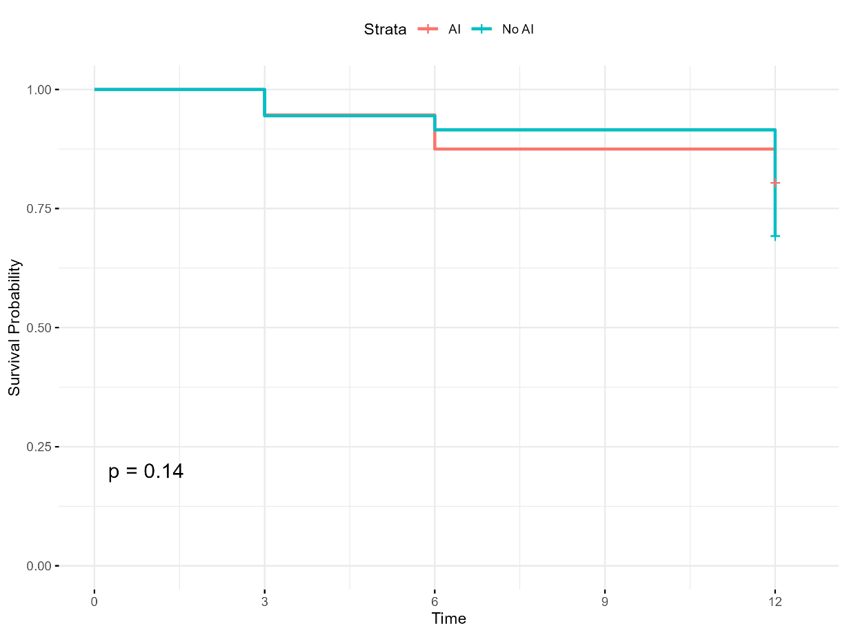
Fig 2: The Kaplan-Meier survival curves for patients with adrenal insufficiency compared with those without among HIV positive patients with a CD4 count less than 100 cells per mm³

Predictors of mortality:
As the presence of AI did not predict mortality, the predictors for premature were assessed for the entire group. Mortality was associated with the presence of skin pigmentation (51%) and poor appetite (77%). With respect to the lab tests random cortisol, ACTH were associated with increased mortality risk, whereas opiate use was protective against mortality.
A logistic regression analysis was undertaken. (Table 5). For every 50 nmol/L increase in the basal cortisol, this was associated with a 14% increase in the likelihood of mortality (OR = 1.14, (95%CI:1.08, 1.21); p<0.001). Opiate use was associated with a 45% reduction in the likelihood of mortality (OR = 0.55, (95%CI: 0.0.33, 0.87); p=0.013. For every 100 pg/L increase in the plasma ACTH, this was associated with a 17% increase in the likelihood of death (OR = 2.17, (95%CI:1.35, 3.72); p<0.003). Patients with a self-reported increased skin pigmentation had a 51% increase in the odds of mortality (OR = 1.51 (95%CI: 1.03, 2.22) but this was not universally the result of primary hypoadrenalism p=0.033). The presence of a poor appetite was associated with a 77% likelihood of premature death (OR=1.77 (95%CI: 1.11, 2.90); p=0.020).

After adjusting for several factors, as shown in Table 5, the only features which were independently associated with premature mortality were systolic, diastolic blood pressures, random cortisol and opiate use. Every 10 mmHg increase in diastolic blood pressure was associated with a 30% increase in likelihood of mortality (aOR = 1.30 (95%CI: 1.07, 1.59), p=0.01). Every 10 mmHg increase in systolic blood pressure was associated with an 18% reduction in the odds of mortality (aOR = 0.82 (95%CI: 0.71, 0.95) p=0.010). Every 50 nmol/L increase in random cortisol was associated with a 14.7% likelihood mortality (aOR = 1.147 (95%CI:1.082, 1.217) p<0.001). While opiate use was associated with a 44.5% reduction in the odds of mortality (aOR = 0.555 (95%CI:0.33, 0.933), p=0.026).

Table 5: Bivariate and Multivariate analysis of factors associated with time to mortality of patients in the entire cohort.
Characteristic | N | Bivariate |  |  | Multivariable
Characteristic | N | OR¹ | 95% CI¹ | p-value | Adj. OR³ (95% CI)¹ | p-value
History
Increased_pigmentation_skin | 525 | 1.51 | 1.03, 2.22 | 0.033 | 1.26 (0.76, 2.08) | 0.379
Poor_appetite | 535 | 1.77 | 1.11, 2.90 | 0.02 | 1.25 (0.72, 2.19) | 0.425
Liking_for_salt | 536 | 1.33 | 0.92, 1.95 | 0.13 | 1.27 (0.85, 1.90) | 0.244
Nausea | 538 | 1.4 | 0.96, 2.05 | 0.08 | 1.08 (0.66, 1.78) | 0.754
BP_diastolic | 553 | 1.13 | 0.98, 1.30 | 0.088 | 1.30 (1.07, 1.59) | 0.010
BP_systolic | 553 | 0.93 | 0.84, 1.03 | 0.2 | 0.82 (0.71, 0.95) | 0.010
Investigations
Haemoglobin | 558 | 0.92 | 0.85, 1.00 | 0.06 | 0.93 (0.85, 1.02) | 0.138
GE_c_diff | 549 | 0.49 | 0.14, 1.32 | 0.2 | 0.61 (0.19, 1.91) | 0.394
Random_cortisol | 548 | 1.14 | 1.08, 1.21 | <0.001 | 1.15 (1.08, 1.22) | <0.001
Basal_cortisol | 167 | 1.06 | 0.98, 1.15 | 0.13
ACTH | 548 | 2.17 | 1.35, 3.72 | 0.003 | 1.25 (0.95, 1.65) | 0.115
Cryptococcus_neoformans | 549 | 1.72 | 0.79, 3.67 | 0.2 | 1.77 (0.71, 4.40) | 0.217
Pneumonia | 549 | 0.66 | 0.34, 1.21 | 0.2 | 0.68 (0.35, 1.34) | 0.269
cd4 | 557 | 0.77 | 0.56, 1.06 | 0.11 | 1.02 (0.70, 1.47) | 0.935
Viral load | 126 | 1.08 | 0.98, 1.21 | 0.14 | 1.02 (0.95, 1.10) | 0.554
Medications
Opiates | 563 | 0.55 | 0.33, 0.87 | 0.013 | 0.56 (0.33, 0.93) | 0.026
Fluconazole | 563 | 1.64 | 0.98, 2.71 | 0.056 | 1.61 (0.90, 2.87) | 0.108
1 Odds Ratio; 2 95% Confidence interval; 3 Adjusted Odds Ratio
please define the abbreviations

Prediction of AI using artificial intelligence (artintell)
In this study, we explored the utility of machine learning to predict adrenal insufficiency among 550 patients, of whom 43 were identified as having probable adrenal insufficiency. The dataset was divided into training and testing subsets, with 33 AI patients and 453 non-AI in the training set, and 10 AI patients and 54 non-AI in the testing set. After initial attempts with logistic regression proved unsatisfactory, a small fully connected neural network with two hidden layers (16 and 8 units, respectively) outperformed other approaches. As shown in Table 6 (Performance Metrics of the Best Neural Network), this model achieved a training sensitivity of 1.00 and specificity of 0.95, and a testing sensitivity of 0.80 and specificity of 0.94.
Figure 2 (ROC Curve for the Testing Data; AUC = 0.950) illustrates the network’s strong discriminative capability. Figure 3 (Feature Importances According to the Best Neural Network Model) highlights the relative influence of each variable, underscoring the high predictive value of serum sodium and random basal serum cortisol results. Though the limited size of this dataset precludes definitive conclusions, these proof-of- concept results underscore the promise of targeted machine learning strategies inAI correctly identifying AI
Table 6: Performance Metrics of the Best Neural Network

Performance Metric | Train Dataset | Test Dataset
Accuracy | 0.953 | 0.922
Sensitivity | 1.000 | 0.800
Specificity | 0.949 | 0.944
Precision | 0.589 | 0.727
Recall | 1.000 | 0.800
F1 Score | 0.742 | 0.762
ROC AUC Score | 0.994 | 0.950
Table 6: Performance Metrics of the Best Neural Network

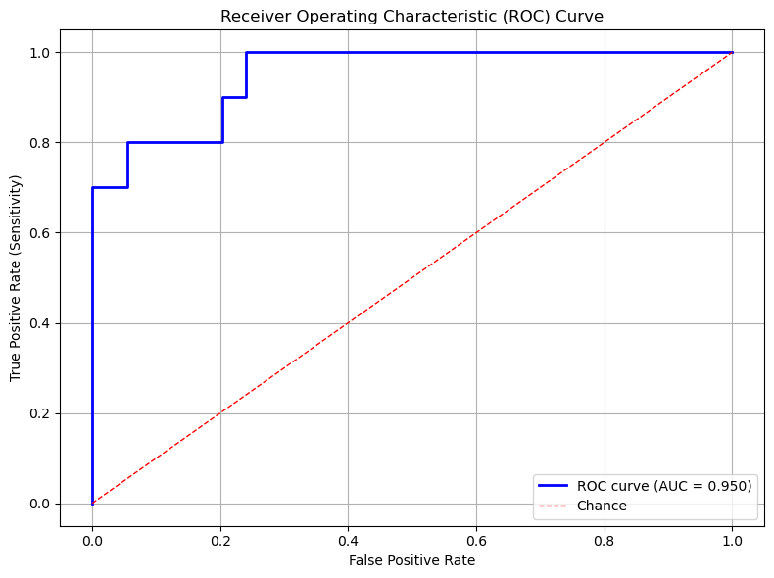
Figure 2: ROC Curve for the Testing Data (AUC = 0.950)
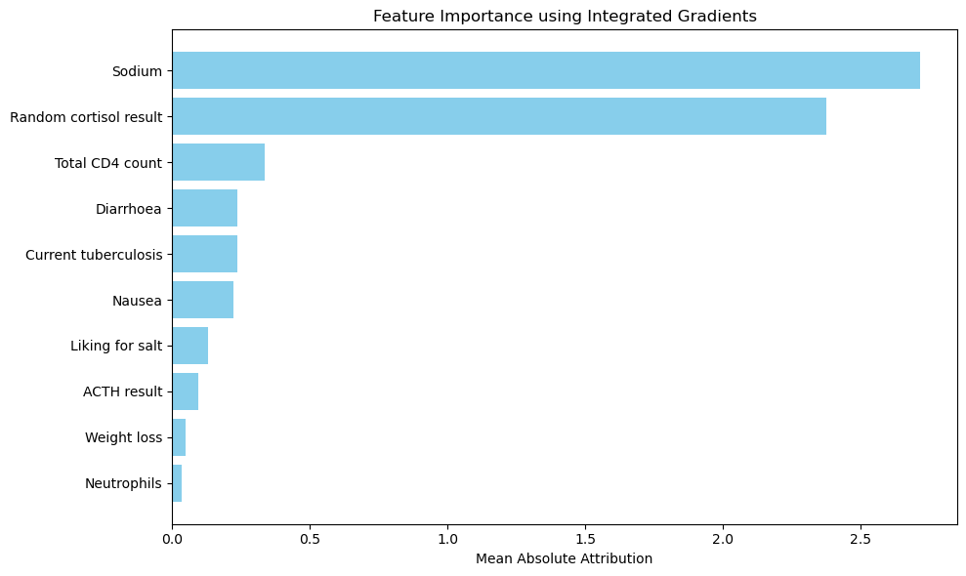
Figure 3: Feature Importances According to the Best Neural Network Model

Link to the code:
https://anonymous.4open.science/r/adrenal-insufficiency-prediction-with-AI-F59C/

Discussion:

In the first paragraph, please summarise the most important results

Please discuss each positive result in a separate paragraph

Next describe the strengths, please

Next describe the weaknesses

Next describe the conclusions only on the basis of your results, please

.

A.I. prediction of AI
Despite the limited size of the dataset, the application of a small fully connected neural network provided encouraging evidence that key features, most notably Sodium and Random Cortisol Results—may be particularly influential in predicting adrenal insufficiency. The model demonstrated high sensitivity and specificity, and its receiver operating characteristic curve showed a strong area under the curve (AUC = 0.950), underscoring its capacity to discriminate between individuals at heightened risk. These findings suggest that a targeted machine learning approach could complement standard clinical evaluations and laboratory tests for the early identification of adrenal insufficiency. Nonetheless, the modest cohort size and variations in feature documentation limit the broader generalizability of these preliminary outcomes, making further research with larger, more comprehensive datasets essential to confirming and refining the practical utility of such models in clinical settings.

Strengths :
This is the biggest study on patients with advanced HIV Africa confirming AI, its associated aetiologies and mortatlity.

The weaknesses
A small AI sample size.
Telephonic and clinic follow up to check post discharge mortality.
It is a single center study and may thus its findings may not be generalizable.
Unavailability of the LC/MS which is the new GOLD Standard for steroid analysis.

Conclusion:
The largest African study on hypoadrenalism in advanced HIV revealed the AI incidence of 6.21% and overall mortality of 26.9%. We feel that screening for AI is warranted in advanced HIV, to mitigate the risk of death. The majority of the opportunistic infections were tuberculosis, pneumonia and cryptococcal infections. Extra-pulmonary tuberculosis and cryptococcal infections correlated with the aetiology of mortality in patients with AI and may be AI-defining illnesses in advanced HIV, while elevated cortisol was associated with increased odds of death.

Uncategorized References
- Dunlop D. Eight-six cases of Addison's disease. British medical journal. 1963;2(5362):887.
- Betterle C, Morlin L. Autoimmune Addison’s disease. Pediatric adrenal diseases. 2011;20:161-72.
- Ross IL, Levitt NS. Addison’s disease symptoms–a cross sectional study in urban South Africa. PLoS One. 2013;8(1):e53526.
- Mofokeng TR, Beshyah SA, Mahomed F, Ndlovu KC, Ross IL. Significant barriers to diagnosis and management of adrenal insufficiency in Africa. Endocrine connections. 2020;9(5):445- 56.
- Mofokeng TRP, Ndlovu KCZ, Beshyah SA, Ross IL. Tiered healthcare in South Africa exposes deficiencies in management and more patients with infectious etiology of primary adrenal insufficiency. Plos one. 2020;15(11):e0241845.
- Goliber T. The status of the HIV/AIDS epidemic in Sub-Saharan Africa. Population Reference Bureau. 2002.
- Hofbauer LC, Heufelder AE. Endocrine implications of human immunodeficiency virus infection. Medicine. 1996;75(5):262-78.
- Boulle A, Schomaker M, May MT, Hogg RS, Shepherd BE, Monge S, et al. Mortality in patients with HIV-1 infection starting antiretroviral therapy in South Africa, Europe, or North America: a collaborative analysis of prospective studies. PLoS medicine. 2014;11(9):e1001718.
- Arlt W. Adrenal insufficiency. Clinical medicine. 2008;8(2):211.
- Husebye ES, Pearce SH, Krone NP, Kämpe O. Adrenal insufficiency. The Lancet. 2021;397(10274):613-29.
- Eledrisi MS, Verghese AC. Adrenal insufficiency in HIV infection: a review and recommendations. The American journal of the medical sciences. 2001;321(2):137-44.
- Bornstein SR. Predisposing factors for adrenal insufficiency. New England Journal of Medicine. 2009;360(22):2328-39.
- Afreen B, Khan KA, Riaz A. Adrenal insufficiency in Pakistani HIV infected patients. Journal of Ayub Medical College Abbottabad. 2017;29(3):428-31.
- Odeniyi I, Fasanmade O, Ajala M, Ohwovoriole A. Adrenocortical function in Nigerians with human immunodeficiency virus infection. Ghana Medical Journal. 2013;47(4):171.
- Bergthorsdottir R, Leonsson-Zachrisson M, Odén A, Johannsson G. Premature mortality in patients with Addison’s disease: a population-based study. The Journal of Clinical Endocrinology & Metabolism. 2006;91(12):4849-53.
- Johannsson G, Falorni A, Skrtic S, Lennernäs H, Quinkler M, Monson JP, et al. Adrenal insufficiency: review of clinical outcomes with current glucocorticoid replacement therapy. Clinical endocrinology. 2015;82(1):2-11.
- Vogeser M, Kratzsch J, Ju Bae Y, Bruegel M, Ceglarek U, Fiers T, et al. Multicenter performance evaluation of a second generation cortisol assay. Clinical Chemistry and Laboratory Medicine (CCLM). 2017;55(6):826-35.
- Holst JP, Soldin SJ, Tractenberg RE, Guo T, Kundra P, Verbalis JG, et al. Use of steroid profiles in determining the cause of adrenal insufficiency. Steroids. 2007;72(1):71-84.
- Bancos I, Hazeldine J, Chortis V, Hampson P, Taylor AE, Lord JM, et al. Primary adrenal insufficiency is associated with impaired natural killer cell function: a potential link to increased mortality. European journal of endocrinology. 2017;176(4):471-80.
- Christ-Crain M, Stolz D, Jutla S, Couppis O, Müller C, Bingisser R, et al. Free and total cortisol levels as predictors of severity and outcome in community-acquired pneumonia. American journal of respiratory and critical care medicine. 2007;176(9):913-20.

